**Homework 12**

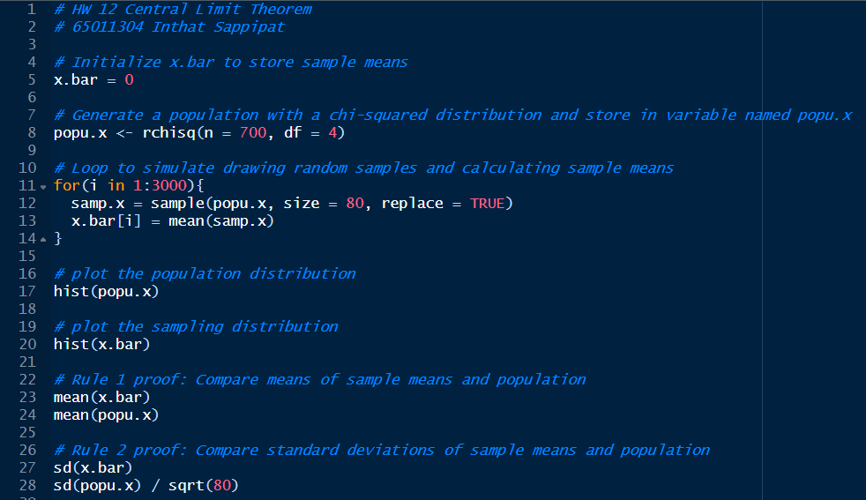**Code:**

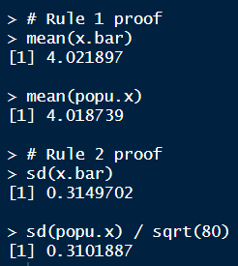**Result:**

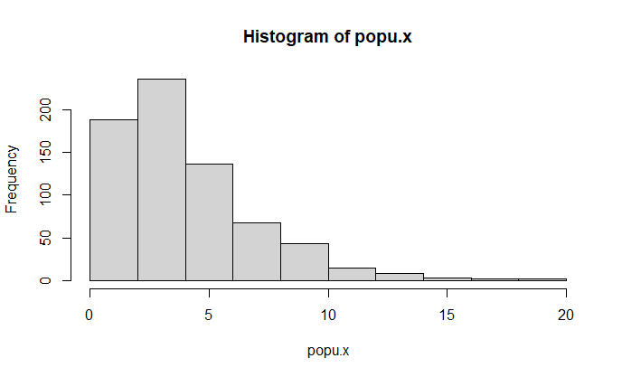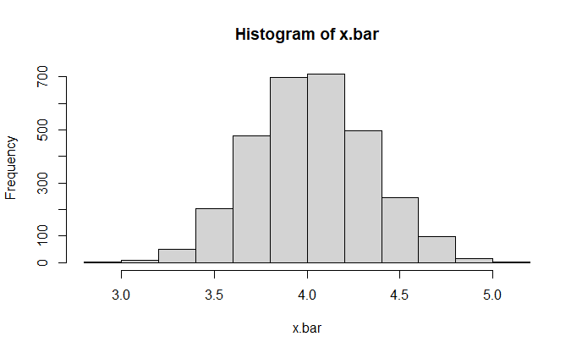**Histogram:**

**Conclusion:**

From the experiment, in rule 1, the mean of the sample means (mean(x.bar)) is close to the mean of the population (mean(popu.x)). This is in line with the first rule of the CLT, which states that the mean of the sampling distribution approaches the mean of the population as the sample size increases. In rule 2, the standard deviation of the sample means (sd(x.bar)) isclose to the standard deviation of the population divided by the square root of the sample size (sd(popu.x) / sqrt(80)). This is consistent with the second rule of the CLT, stating that the standard deviation of the sampling distribution decreases as the sample size increases. The histograms of the population (hist(popu.x)) and the sampling distribution (hist(x.bar)) demonstrate the transformation from a chi-squared distribution to a normal distribution. As per the CLT, the sampling distribution tends to be normal, regardless of the shape of the original population distribution.